­­

Drawing application report

Team members:

* Mohamed Mohamed abdelhakem (ID :43)
* Yousef mohamed fathy (ID :63)

User guide:­­

* The user will be able to draw any of the six supported shapes by selecting it then click on the canvas then dragging the mouse to resize the shape required to draw.
* You have the ability to select any supported shape, once you select a supported shape, you will be able to move or resize it by dragging any of the vertices of the shape.
* You also can select the shape and delete it by firing the button with trash icon.
* To undo an operation on a shape you fire back button in the image below and to redo you fire the forward button.
* You have a restriction to undo 20 operation backwards and redo 20 operation forwards. 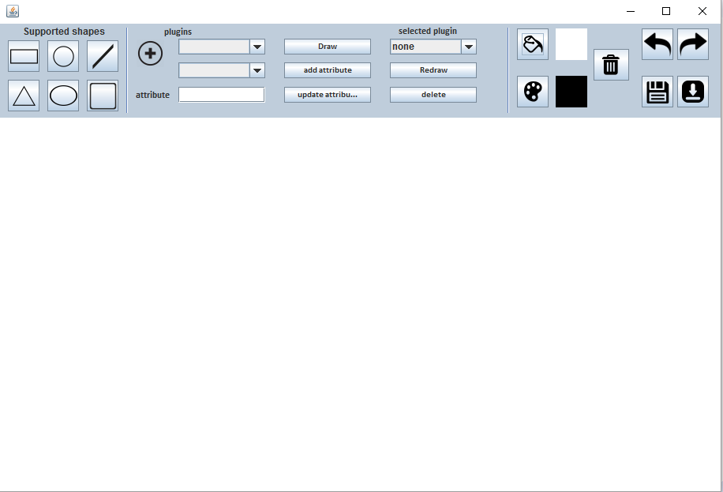
* You can select the color with which you draw the shapes and after drawing if you would like to fill the shape select a fill color and click on the shape.
* You can also load an external jar file contain shapes classes by using the plugin options from the add button then choosing jar file.
* You can select the drawn plugins from the combo box in the image and you can update its attributes or delete the shape.
* Saving a drawing plate is a must, so the application supports saving the drawn shapes in xml and Json files. You are restricted to these two file extensions any other extension will be rejected by the application.
* Loading is in the same way as saving. If you want to load a file contains drawn plugins you have to load the jar containing plugins first.

Design Decisions:

* ­­we got restricted to implement plugin design in a non-friendly way to avoid the errors accompanied by drawing, moving and resizing unsupported shapes.
* For all supported shapes, we implemented a user friendly interface to facilitate dealing with it.

Sample runs:

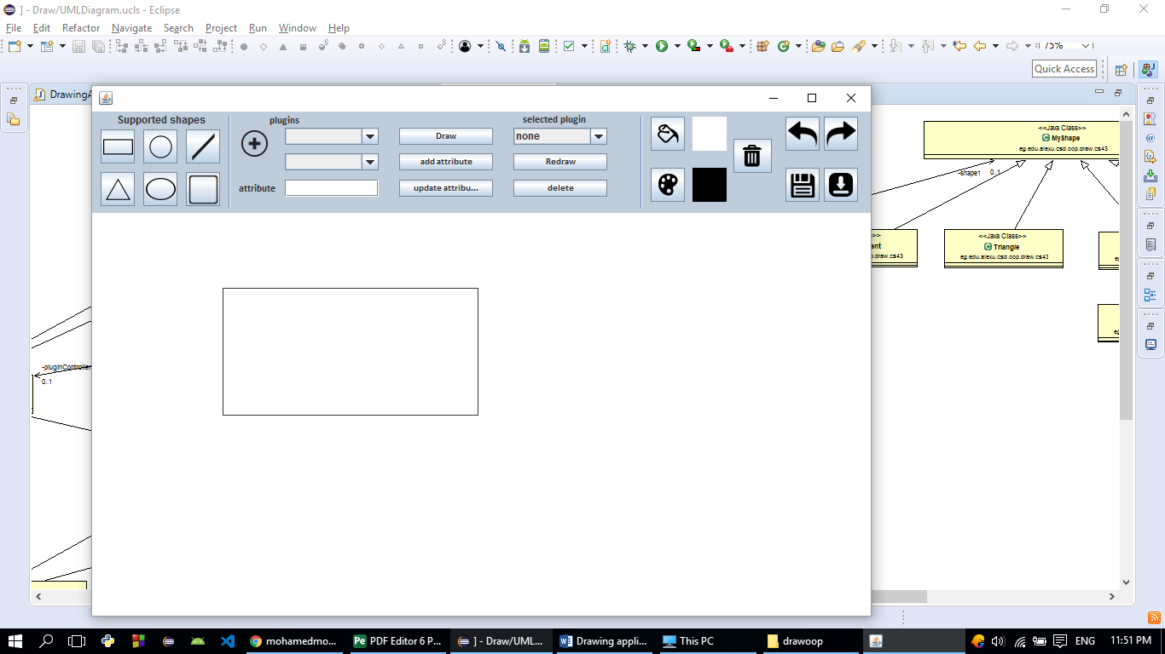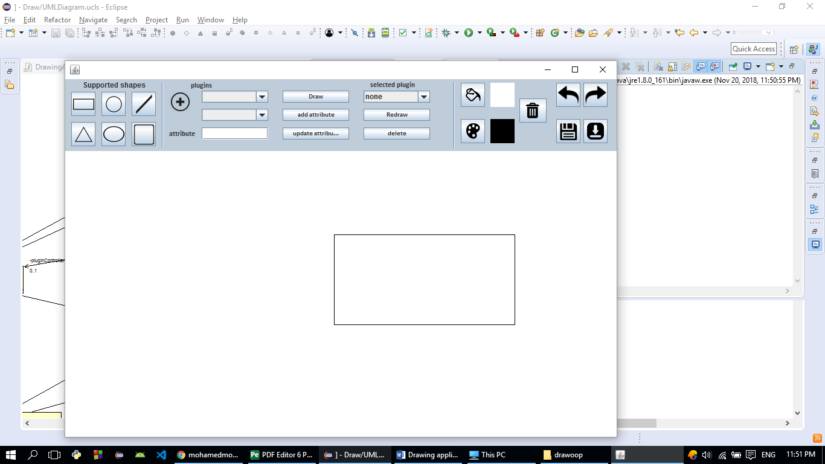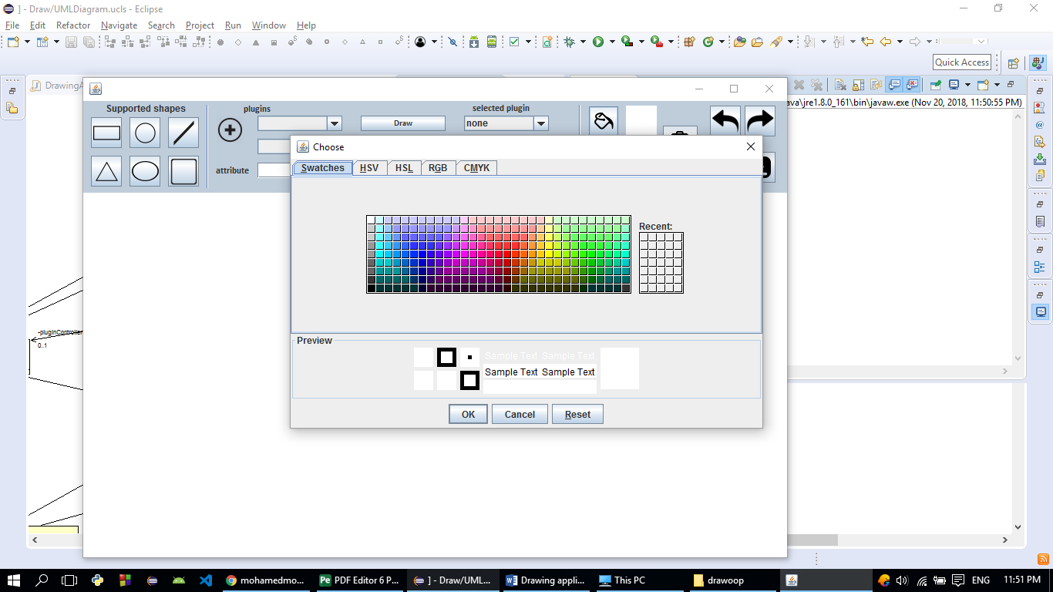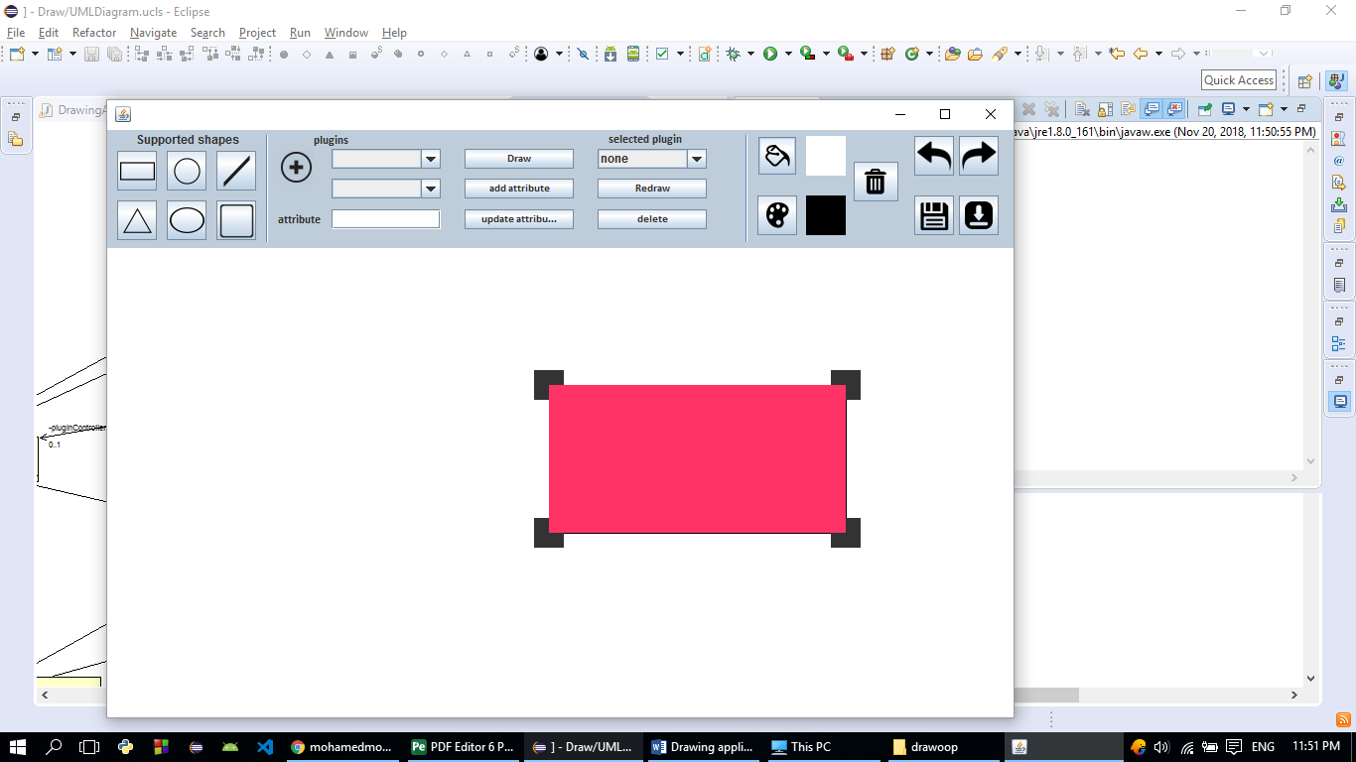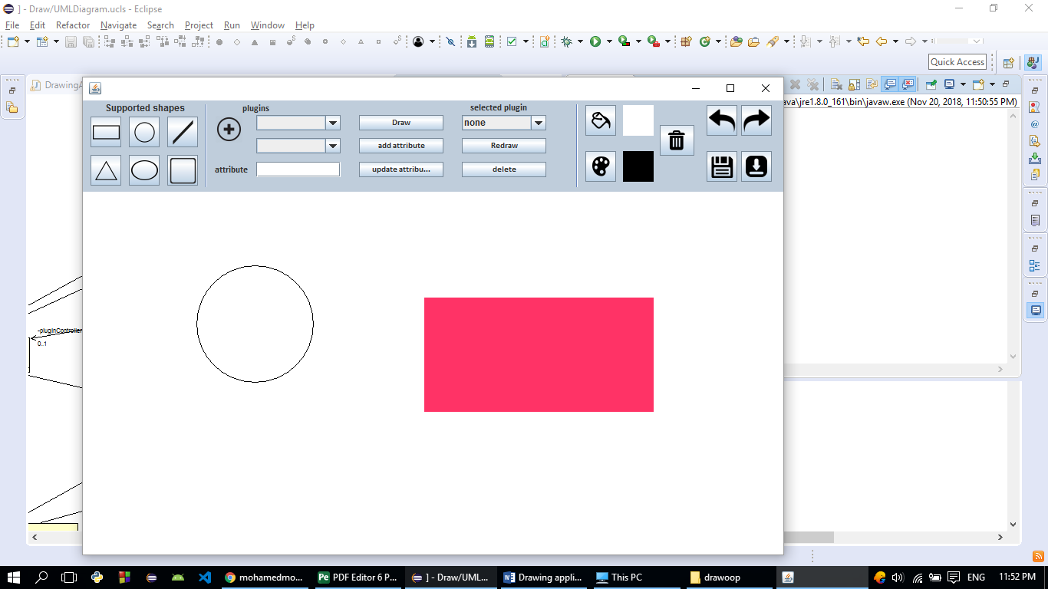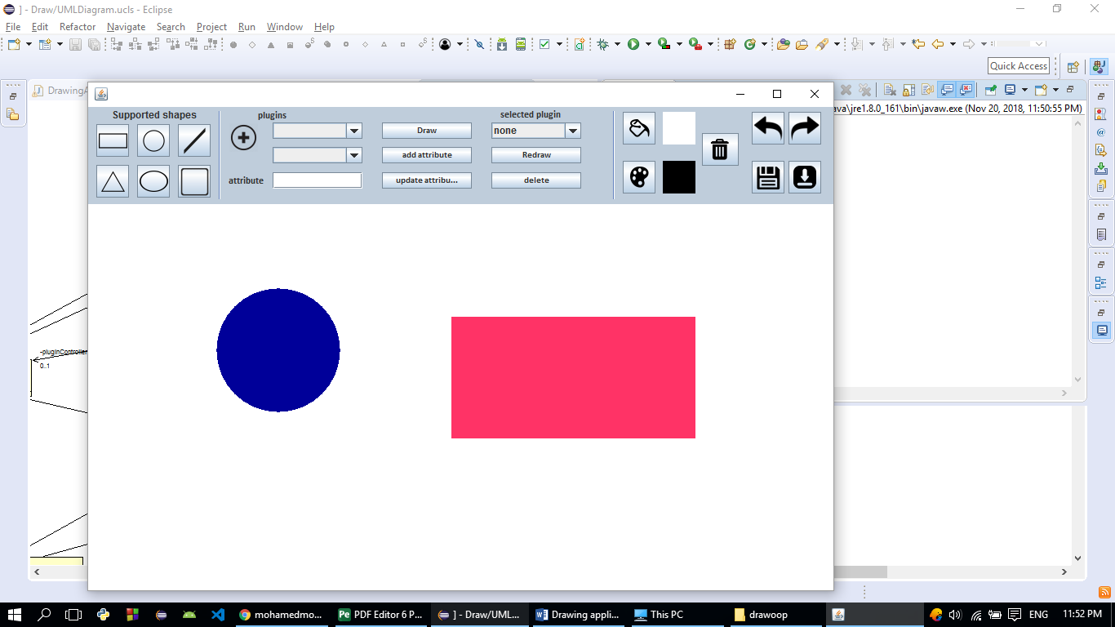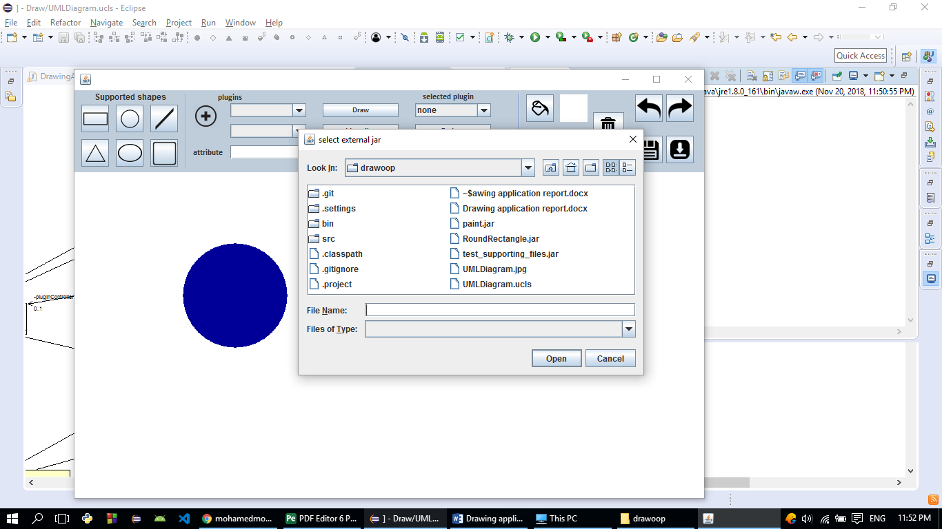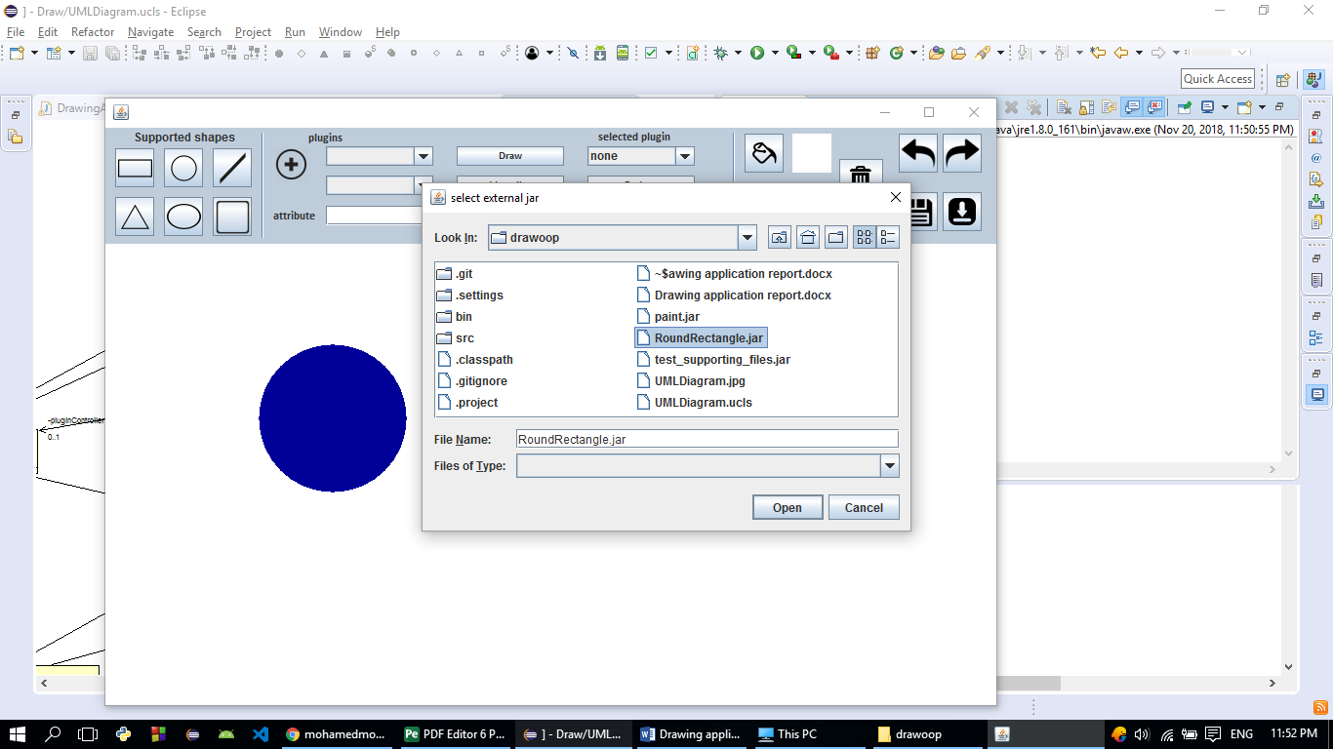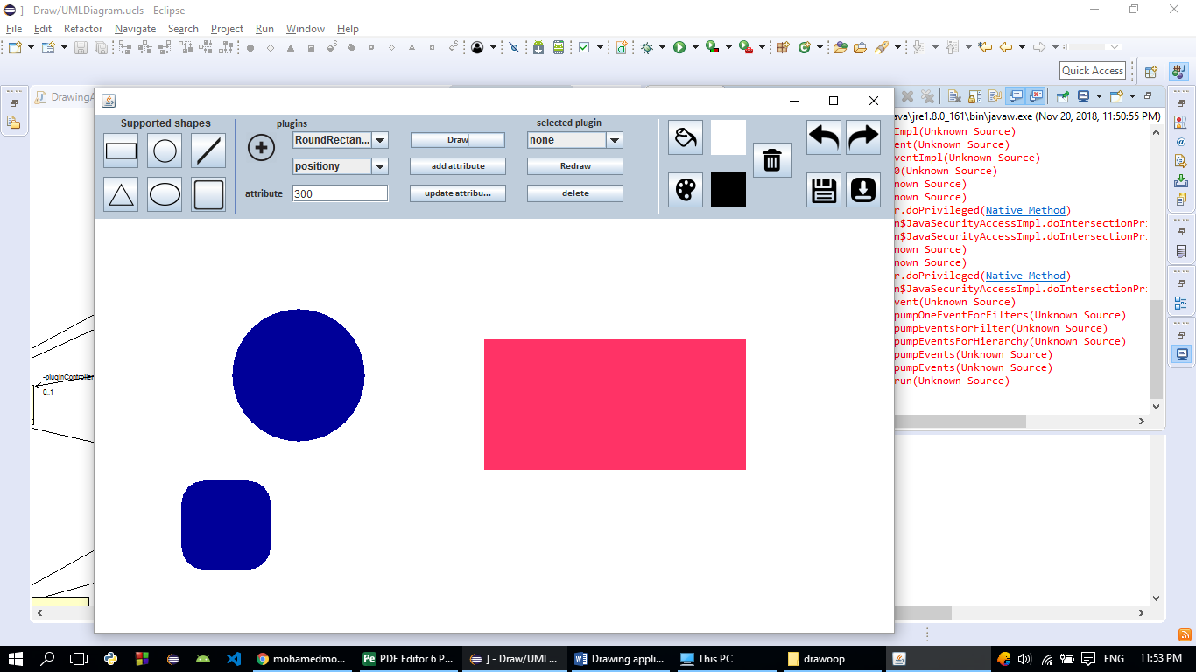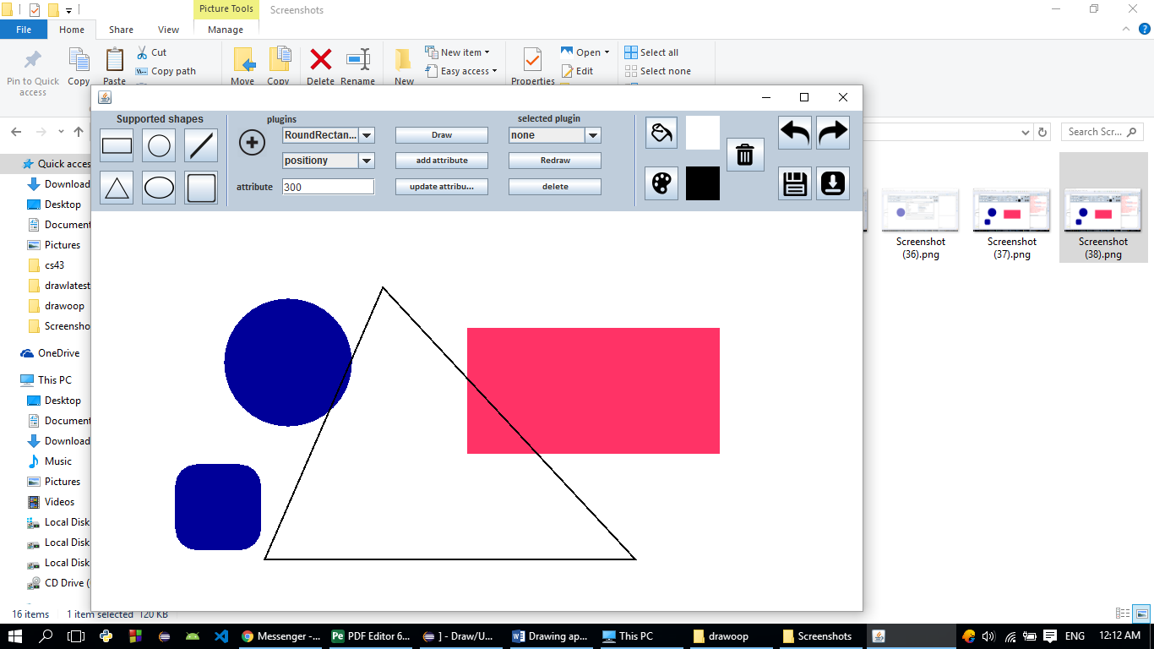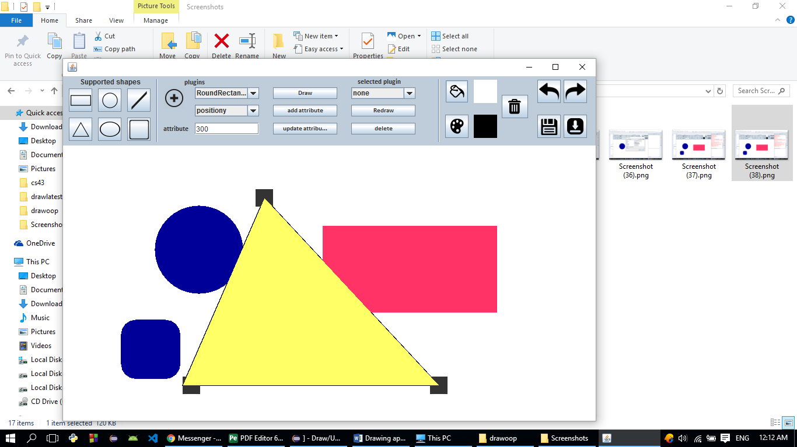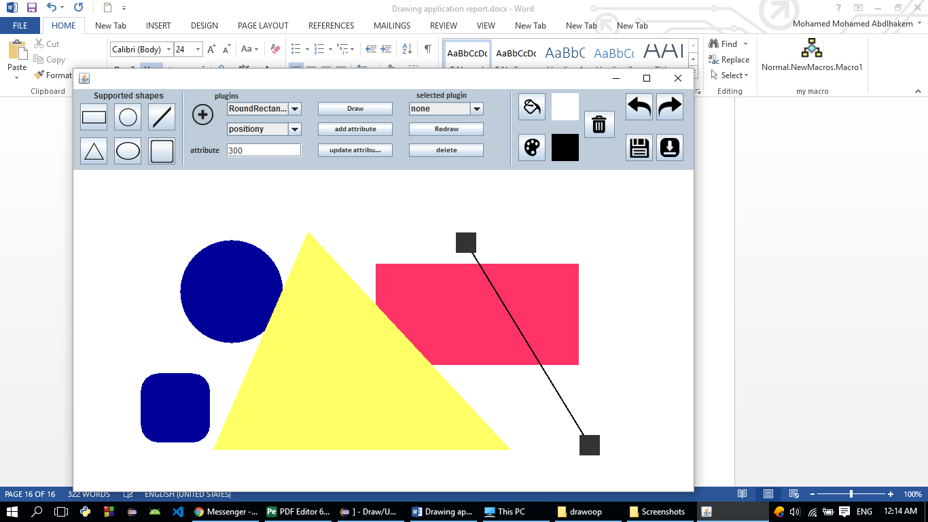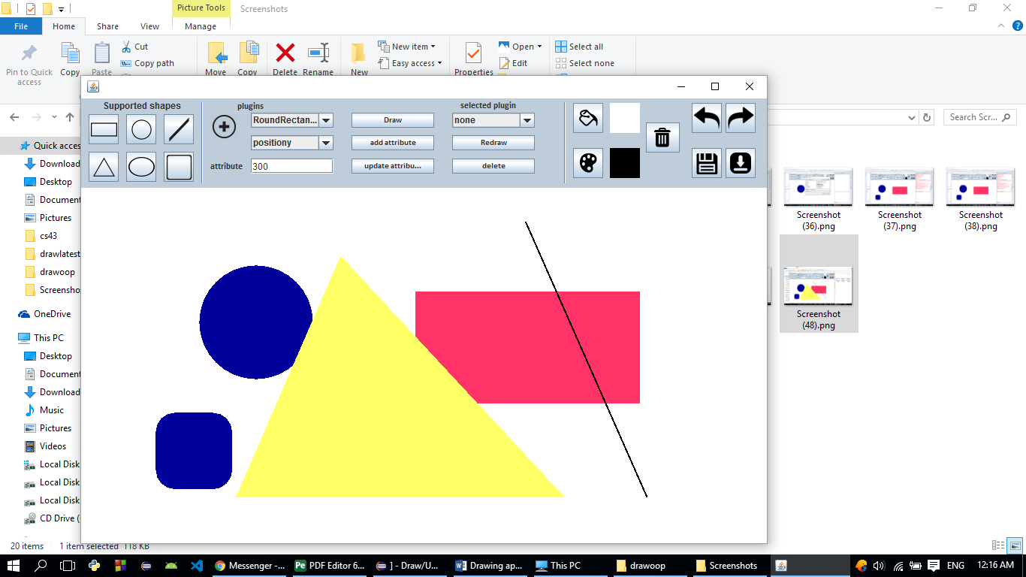

UML DESIGN:

Note: the screen shots of UML design is not better as viewed on eclipse.

